The maximum heart rate of a person is often said to be related to age by the equation

Max = 220 – Age

Suppose this hypothesis is to be empirically examined and 15 people of varying ages are tested for their maximum heart rate, with the results tabulated below.

|  |  |  |  |  |  |
| --- | --- | --- | --- | --- | --- |
| ***Case*** | ***Age*** | ***Max Rate*** | ***Case*** | ***Age*** | ***Max Rate*** |
| ***1*** | ***18*** | ***202*** | ***9*** | ***72*** | ***153*** |
| ***2*** | ***23*** | ***186*** | ***10*** | ***19*** | ***199*** |
| ***3*** | ***25*** | ***187*** | ***11*** | ***23*** | ***193*** |
| ***4*** | ***35*** | ***180*** | ***12*** | ***42*** | ***174*** |
| ***5*** | ***65*** | ***156*** | ***13*** | ***18*** | ***198*** |
| ***6*** | ***54*** | ***169*** | ***14*** | ***39*** | ***183*** |
| ***7*** | ***34*** | ***174*** | ***15*** | ***37*** | ***178*** |
| ***8*** | ***56*** | ***172*** |  |  |  |

We can implement the regression model using the following code.

|  |
| --- |
| ### Create the Data  Age=c(18, 23, 25, 35, 65, 54, 34, 56, 72,  19, 23, 42, 18, 39, 37) MaxRate=c(202,186,187,180,156,169,174,  172,153,199,193,174,198,183,178)  lm(MaxRate~Age) |

The regression coefficients (i.e. estimates for intercept and slope) are presented in the following code.

|  |
| --- |
| Call: lm(formula = MaxRate ~ Age)  Coefficients: (Intercept)          Age     210.0485       -0.7977 |

The regression equation is therefore

$$\hat{y}=210.05-0.797 x$$

Where x is the observed value for age, and $\hat{y}$ is the predicted value for maximum heart rate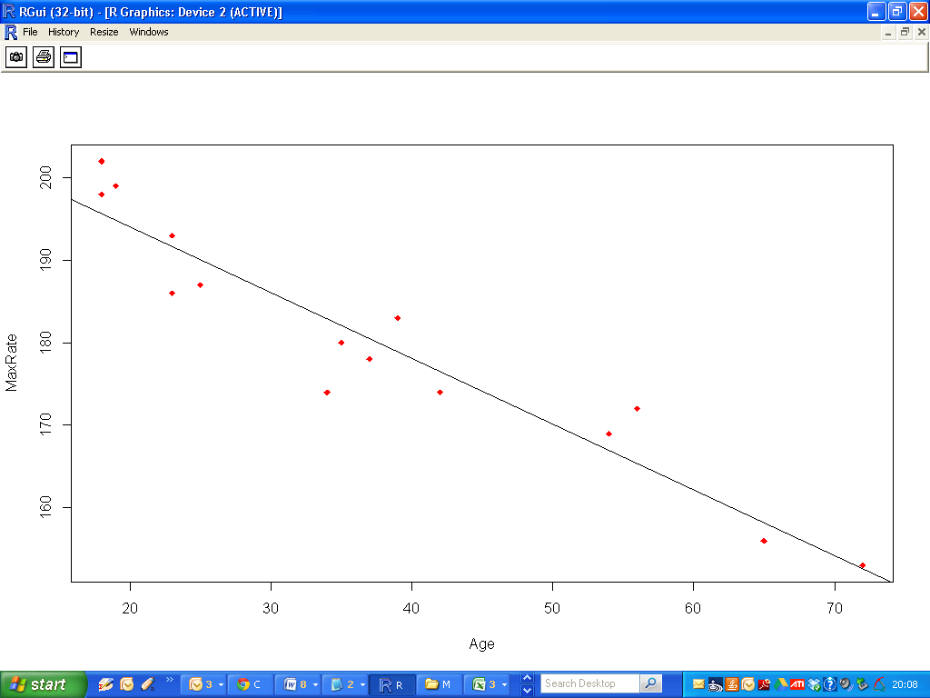

We can determine 95% confidence intervals for this regression estimates.

|  |
| --- |
| > confint(Fit)  2.5 % 97.5 %  (Intercept) 203.854813 216.2421034  Age -0.948872 -0.6465811 |

A full statistical summary can be created using the summary command

|  |
| --- |
| > summary(lm(MaxRate~Age))  Call:  lm(formula = MaxRate ~ Age)  Residuals:  Min 1Q Median 3Q Max  -8.9258 -2.5383 0.3879 3.1867 6.6242  Coefficients:  Estimate Std. Error t value Pr(>|t|)  (Intercept) 210.04846 2.86694 73.27 < 2e-16 ***  Age -0.79773 0.06996 -11.40 3.85e-08 ***  ---  Signif. codes: 0 ‘***’ 0.001 ‘**’ 0.01 ‘*’ 0.05 ‘.’ 0.1 ‘ ’ 1  Residual standard error: 4.578 on 13 degrees of freedom  Multiple R-squared: 0.9091, Adjusted R-squared: 0.9021  F-statistic: 130 on 1 and 13 DF, p-value: 3.848e-08 |

For the time being we are interested specifically in the “coefficients” section.

|  |
| --- |
| Coefficients:  Estimate Std. Error t value Pr(>|t|)  (Intercept) 210.04846 2.86694 73.27 < 2e-16 ***  Age -0.79773 0.06996 -11.40 3.85e-08 *** |

As well as the regression coefficients, we have the test statistics and corresponding p-values for a series of hypothesis tests that are discussed in the notes.

These tests are to assess if the true parameter values (that the regression coefficients are estimates for) are zero.

If we fail to the reject the null hypothesis for “AGE”, we would infer that age is not a useful explanatory variable for “MaxRate”.